**Music supplement to Lute News 41 (March 1997): The Complete Lute Solos of Robert Kindersley/Kennersley, Robert Taylor and Greeves**

This music supplement collects together the few lute solos of three English composers.

**Robert Kindersley/Kennersley**

‘Robert Kennersly’ is recorded as one of the lutenists playing at the Merchant Taylor’s banquet given in honour of King James, Queen Anne and Prince Henry on 16 July 1607. ‘Ro. Kindersley/Rob. kendersly’ contributed two sacred songs to Sir William Leighton’s *Teares or Lamentacions of a Sorrowfull Soule*, 1614. One, ‘O God to whom all hearts are seen’, is for four voices accompanied by six-part mixed consort [L, B, C, TV, F, BV] and the other, ‘Judge them, O Lord, which we pursue’, is for five unaccompanied voices. The lute part is for seven-course lute. In February 1626 ‘Robert Kindersley’ was appointed ‘lutenist’ to King Charles in the place of Roger Maior, backdated to 16 January. In 1634 'Robert Kindersley' also played contratenor violin in James Shirley's masque *The Triumph of Peace* with music by William Lawes. In the royal accounts his name is also spelt ‘Kinnersley, Kindesley, Kendersley; and in 1631 he was also listed as ‘Basso’ among the ‘violins’. ‘Robert Kynnersley’ was replaced by Robert Tomkins as ‘musician in ordinary for the consort’ on 24th March 1634, the accounts recording that he died on 9 March. His will, signed ‘Robart Kindersley’ [cf. below], is dated 27 February 1634 and proved 11 March. He described himself as ‘musician to his Ma[jes]ty’ and bequeathed his whole estate to his ‘loveinge friend ... Thomas Bowles, barbersurgeon’. There is no mention of wife, children, instruments or music. The variation in surname spelling throughout his life suggests that the four lute solos [three galliards and an almaine] are indeed by the same composer. [Biographical note by Robert Spencer and reproduced here with permission.] Two of the galliards have dedications, to ‘Ellnar Stafford’ and ‘fr[ances?]. Tayler’ respectively, who have been impossible to identify. Unusually, both galliards are supplied with additional and more elaborate divisions. Both also resemble John Dowland’s Lady Rich Galliard [Poulton & Lam no. 43] which follows them in the manuscript.

**1.** GB-Cu Dd.5.78.3 [c.1595], f. 7v *Mrs Ellnar Staffords Galliard Ro Kennerley*

GB-Cu Dd.5.78.3, f. 72r untitled [three strains without divisions]

GB-Cu Dd.5.7.8.3, f. 8v *Staffords* [additional divisions to all three strains]

**2.** GB-Cu Dd.5.78.3, f. 8r *Mrs fr. Taylers Galliard Ro Kenn*

GB-Cu Dd.5.7.8.3, f. 8v *Taylers* [additional divisions to all three strains]

**3.** GB-Lbl Add.38539, f. 13r *A gallyard by Robert Kindersley*

**4a.** GB-Lbl Add.38539 [c.1610-40], f. 4r *Allmayne by Robert Kindersley* [in F major]

**4b.** D-B 4022 [early 17c], ff. 46v-47r untitled

**4c.** GB-Lam 603, f. 25v *The Gilly flower*

**4d.** D-B 4022, f. 46v ii *English Almande*

**Robert Taylor**

An entertainment in June 1612 ‘Prepared of an Italian, consort of strange music, consisting of nine instruments with other several instruments, musically concorded with Italian voices’ took place ‘At Master Taylor’s house, one of the king’s majesty’s servants, at Lincoln’s Inn-fields ...’ [cf. W.L. Woodfill, *Musicians in English Society*, 1953, p.238]. Could this be the Robert Taylor who was one of the lutenists, with John and Robert Dowland, Thomas Ford, Philip Rosseter and John Sturt, who played in the Middle Temple and Lincoln’s Inn Maske in February 1613 and the Robert Taylour paid by the Lord Chamberlain as one of the ‘musicians’ at the funeral of James I in 1625? Robert Tailor was appointed as a London city wait, for ‘orpheryon and bass viol and poliphon’ from 1620 until sometime before November 1637, when he is recorded as deceased. Robert Taylor is listed as a member of the musicians of Charles, Prince of Wales, among the ‘lutes and voices’ from 1617 and his autograph is preserved in signed receipts from 1618. He joined the ‘lutes, viols and voices’ of Charles when he became king in 1625 until 1636. He then shared his place with his son John Taylor from 1636 until his death. John was ‘keeper of the instruments’ and one of the ‘viols and voices’ until 1642. He is presumabky different to the earlier composer of an untitled pavan and galliard in the Dublin Virginal Book (IRL-Dtc 410/II, c.1560-80, p. 282 *qd mastyre taylere*; p. 284 untitled).

*Sacred Hymns, consisting of Fifti Select Psalms of David and others, Paraphrastically turned into English Verse. And by Robert Tailour, set to be sung in Five parts, as also to the Viole, and Lute or Orpharion*, was published in 1615 [cf. title page below #5]. The psalm texts are provided with 12 accompaniments consisting of lyra viol tablature under the texted ‘Treble’ voice, ‘Base’, ‘Meane’, ‘Countertenor’ and ‘Tenor’ voices in staff notation without text, followed by a lute intabulation based on the four lower voices as an alternative accompaniment. Two songs ascribed to him are in Och Mus 439 and nineteen pieces for viol or viols are also known. These comprise three almains à 3 in Add.31423 [treble missing], one of these appearing in Simpson 1621, no.46; two preludes ‘RT’ for solo bass viol in Filmer 3; a pavan, 4 almains, 4 corantos, 3 sarabands, a ‘Toye’ and an ‘Ayre’ for lyra viol, in various tunings, in the William Ballet lute book [IRL-Dtc 408/I], Browne Lyra Viol Book (GB-Lam 600), Mansell Lyra Viol Book [US-LAuc M286 M4 L992], Marsh (IRL-Dm Z3.5.13], GB-Och.725, GB-Ob Mus Sch D.247, with two almains and a saraband set à 5 in the Princess Elisabeth of Hessen/Montbuisson Lute Book (D-Kl 4o Mus 108/2].

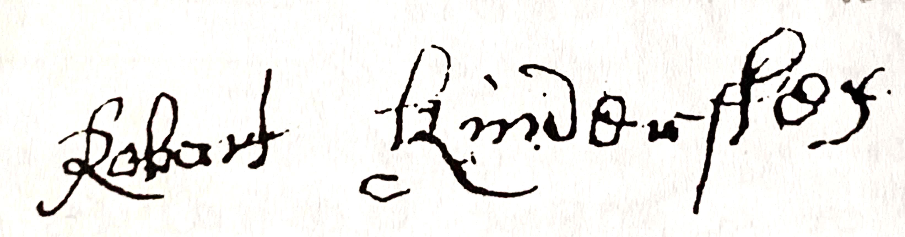

It seems safe to assume that all the above refers to a single musician, who is also the composer of two lute solos, ascribed to ‘mr Robert Taylor’ and ‘Mr Taylor’, reproduced here. These comprise a maske and a pavan, although the divisions to the pavan were set by Thomas Greaves. The maske consists almost certainly of the first and third strains of ‘the first tune’ from Campion’s ‘The Lord’s Maske’ performed 14 February 1612/3. Nicholas Confesse was the choreographer and Robert Taylor was probably a lutenist among the 54 musicians employed for the occasion.

**5.** GB-Otc O.16.2 [c.1630], pp. 122-119 *A pavyn by mr Robert Taylor: ye devisiones sett by mr Thos: Greaves*

**6.** GB-Lam 603 [c.1620-30], f. 27v *Antique maske per Mr Confesso set by Mr Taylor*

The First Tune of The Lords masque (strains AA'C), probably from the entry dance in Campion's *Lords Masque (*1613)

GB-Lbl Add.10444, ff. 54v-55r/104r untitled - à2 (AB)

**Greeves**

The Thomas Greaves who set the divisions to no. 5 above is probably the same man who composed and published *Songes of Sundrie Kindes* in 1604, containing ‘first, Aires to be sung to the Lute, and Bass Violl. Next, Songes of sadnesse, for the Viols and Voyce. Lastly, Madrigalles, for five voyces.’ [facsimile: Scolar Press 1971]. The title page states that Greaves was ‘Lutenist to Sir Henrie Pierrepont, Knight’. Price [Price, D.C., Patrons and Musicians of the English Renaissance 1981, p.150] states that the papers of Sir Francis Willoughby of Wollaton Hall, in Nottinghamshire, record payments in August 1584 to one ‘greves’ for lute strings, in September for more lute strings and mending a lute, and payment of the large sum of £6 13s 8d in October ‘upon his going away’. Price continues that ‘Mr. Greves’ dined with Sir Francis at Wollaton in 1599 [but Price p. 144 states that Francis died in 1596!], suggesting that ‘greves’, the seemingly knowledgeable music servant at Wollaton, was Thomas Greaves. It is a curious coincidence that the Wollaton household employed another knowledgeable music servant, familiar from the entries in the Willoughby lute book [facsimile: Boethius Press, 1978] as ‘a pavuyn Bruzters owt of grenes Booke pag 7’, ‘grenes allman’ and ‘Hayles Galliard sett owt p[er] Ry[chard] Grene’. It occurred to me that Price may have misread ‘greves’ for the ‘grenes’ in the Willoughby papers. However, Mrs Linda Shaw, Assistant Keeper, Department of Manuscripts & Special Collections, Nottingham University, kindly checked the entries in the Willoughby papers, and confirmed that the spelling for all three entries above is definitely with a letter ‘v’ for 'greves', so not 'grene' [see first entry below, reading ‘p(ai)d to grevs for Lute strings’ from the 1584 Account Book Mi A 62]. Thus, Thomas Greaves may have been employed at Wollaton until 1584, transferring to Sir Henry Pierrepoint’s household at Holme Pierrepoint, also in Nottinghamshire, where he remained until after 1604. Thomas Greaves’ surviving lute solos amount only to the divisions to Robert Taylor’s pavan and the galliard ascribed ‘Greeves’ in Dd.5.78.3 [copied by Mathew Holmes c.1595-1600], assuming that the same Greeves, Thomas, was intended. both are by the same man. Alternatively, Greeves who composed the galliard could refer to Richard Greaves, court sackbut player, who replaced Edward Petellain in December 1588 and was employed until he died on 6 June 1600. If so presumably someone else made the arrangement of the galliard for lute.

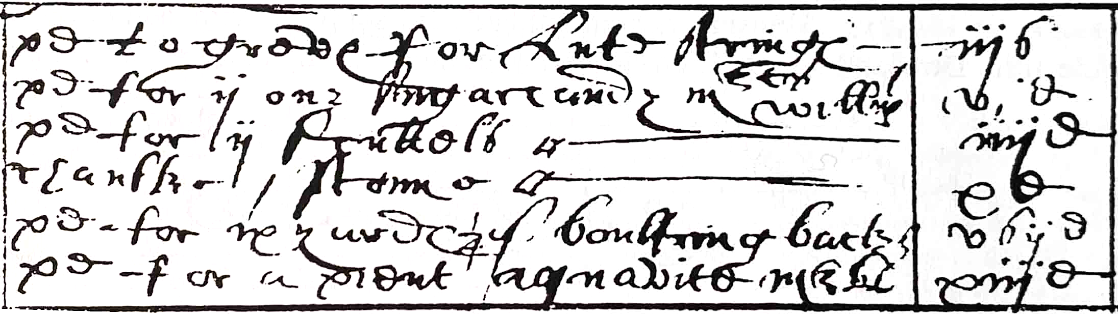

I would like to thank Andrew Ashbee, Lynne Hulse, Linda Shaw and Stewart McCoy for their help and Robert Spencer for providing the Kindersley autograph and biographical sketch.

Ornaments and fingering indications are reproduced as in the original sources without interpretation. Minor editorial corrections have been made without comment.

**7.** Dd.5.78.3, f. 47r [Galliard] [Thomas?] *Greeves*

*John H Robinson - February 1997/revised June 2016*